# Neopixel Strip (WS2812B)

A Neopixel strip is an addressable RGB LED strip using WS2812B or similar LEDs that allow control of each LED individually with a single data line.

**Working Principle:**  
Each LED has a built-in IC that receives and forwards data. A microcontroller sends a specially timed signal controlling the brightness and color of each LED.

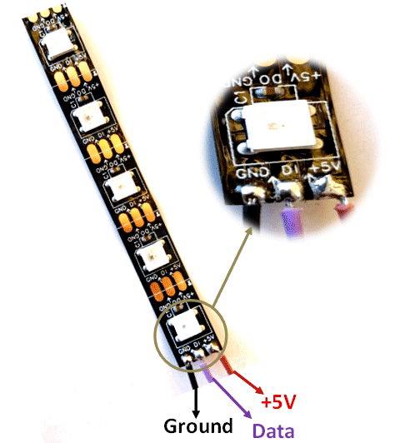**Types**:  
- WS2812 (RGB)  
- WS2812B (improved version)  
- WS2813, SK6812 (RGBW)  
- Strip, Ring, Matrix, or individual module

**Applications**:  
- Decorative lighting  
- Wearables  
- Displays and signs  
- Visual effects in projects  
- LED cubes and art installations

**Advantages**:  
- Individually addressable  
- High brightness  
- Flexible and customizable Fig: NeoPixel Strip  
- Controlled with just one data pin

**Disadvantages**:  
- Requires precise timing (use libraries like Adafruit Neopixel)  
- Sensitive to voltage and power supply  
- Generates heat on high brightness